**Phase 40**

6:43:57

when to use it and when to not

You can use it for testing purpose to check how our ad was working after it and before it.

We don’t use it when we have a specific and exact audience

It will not expand location or age.

Means if we target a specific age group then it will not target other age group thinking that there

can be convergence there it will do so in targeting according to similar topic we selected for targeting around the same age group we selected.

Similarly this is the case in location.

So the expansion happens is of characteristics not of location or age.

You can use it or not

From what teacher has tested

In different cases or scenerios or different strategies different performance is shown.

You cannot say that it will always work good or bad it give mixed performance Many thing depend on its success. It depend on category and budget.

If you have a category that already cover expanded topic(general) then you don’t have to use it.

**Lesson 26:-**

In this lesson we will learn about narrow audience in Facebook

This is a very important concept by this lesson you will learn many options and approaches through which you can target very specific audience or to the point audience or perfect audience

So whether you are talking about promoting your business or you want to select audience for your client so if you understand the concept of narrow audience then you can select audience in many ways and you can experiment with them in many ways

First we will find this where we will see the option of narrow audience in Facebook . Then we will see the practical example here and see the cases where if we want to target a type of audience then how can we do so by narrow audience option

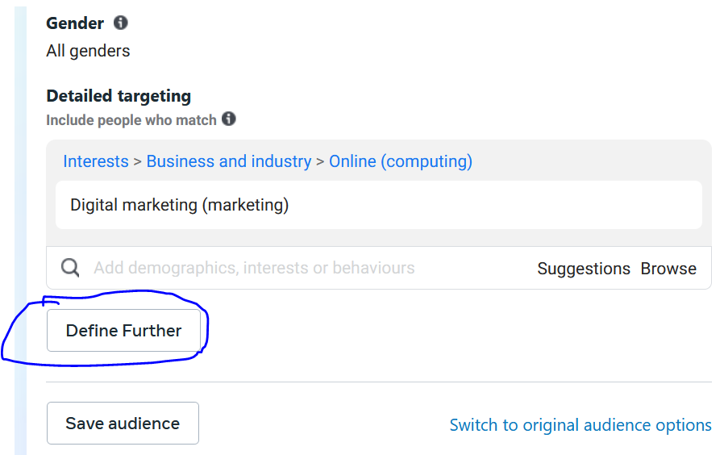

In above image I think marked button named define further is narroe audience now

**Case 1** Here I want target teacher in top universities

You may say that what we have to do is to targetmath teacher and then also target top colleges

SO suppose we first select Math teacher

**Phase 41**

then

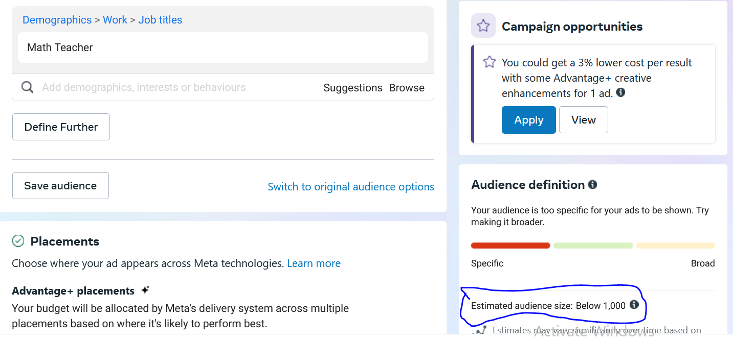

By hovering over the Math Teacher you will see the tooltip saying size is below 1000

But now suppose we choose IIT Delhi

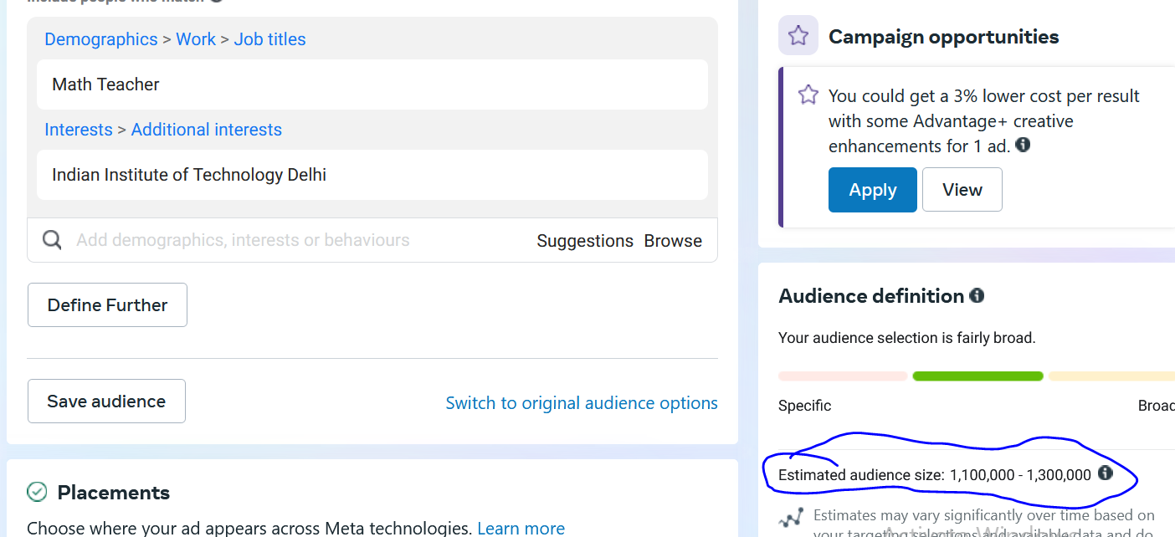

Then we see that size has increased but it was supposed to be reduced as it was targeting match teacher in iit delhi

Becaue we are now targeting match teacher and the people interested in it

Not the math teacher inside the IIT Delhi

So we are actually doing normal targeting but we were supposed to narrow targeting So to do it

First we choose iit delhi

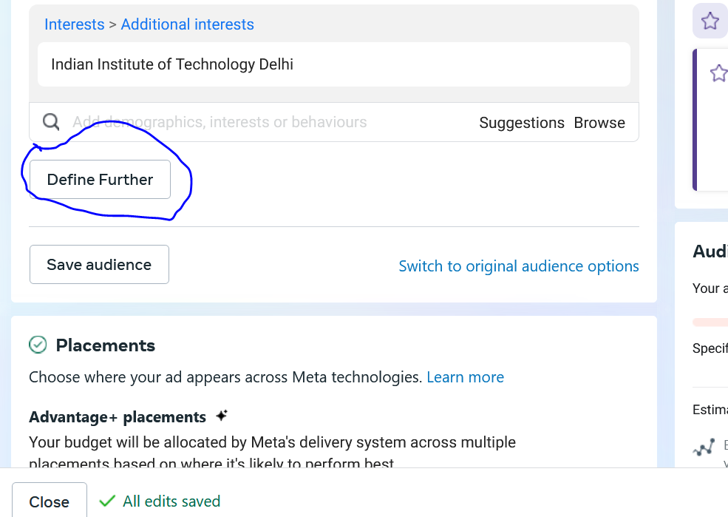

And then click on Define further as marked above

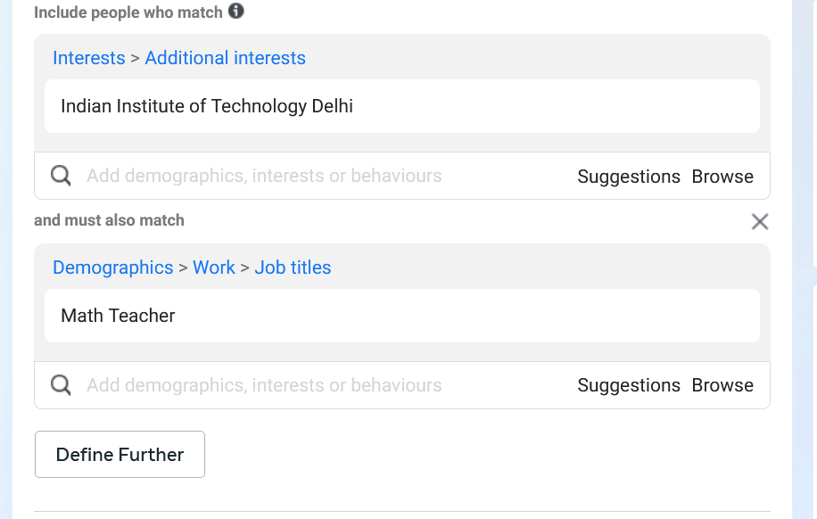

And now in New field we type Math Teacher

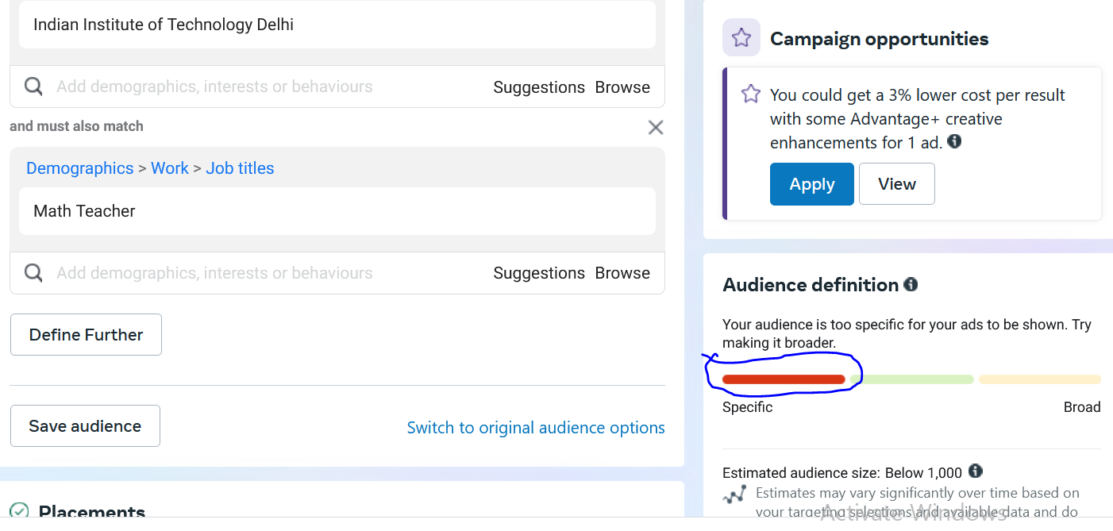

And now you can see the size is decreased and now the targeting audience is specific as told by Facebook in marked above.

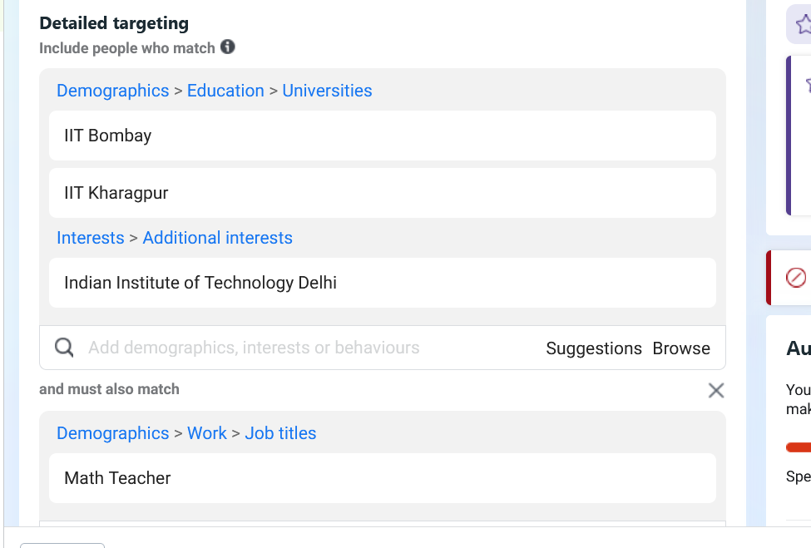

Similarly we choose for other Top Colleges.

You can make an ad group like this or you can make another ad group

Similarly you can do so by doing for Physics Teacher

You can test tha which ad group s performing better

The more specific you are the more accurate the targeting is.

You can do testing. It is not like that you become specific one time only

You can make another ad group and make specific again.

And then you can see which ad group is performing better

We will become specific and see which combination is performing better.

**Case 2**

Now suppose we have a case where we want to target rich parent if we leave parent for now what could be the characteristics of rich people suppose we choose luxury in detailed marketing so I can target luxury based characteristics of people

We can also add luxury goods , first class travel , expensive taste, business travels, real estate, investing etc.

You may see the size is very big when you do so

But we want to target parents also

So for parent we set age group of 25 to 50

Now you see the seze is decresed

Demographics

Demographics are **statistics that describe populations and their characteristics**. Demographic analysis is the study of a population-based on factors such as age, race, and sex.

Now we go to define further and choose parent with adult childeren as a demographic and not choose parent as an interest

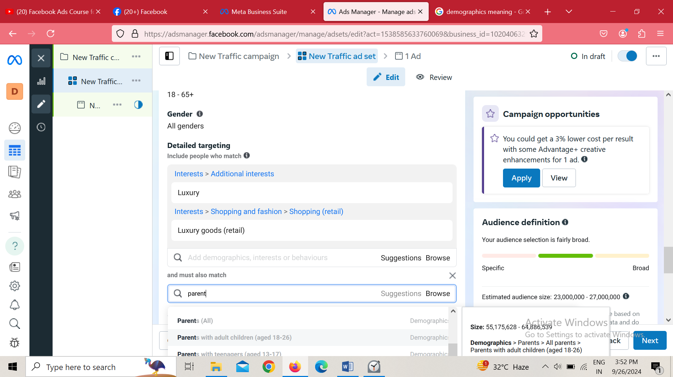

Now you can see the audience is reduced because we have gone specific

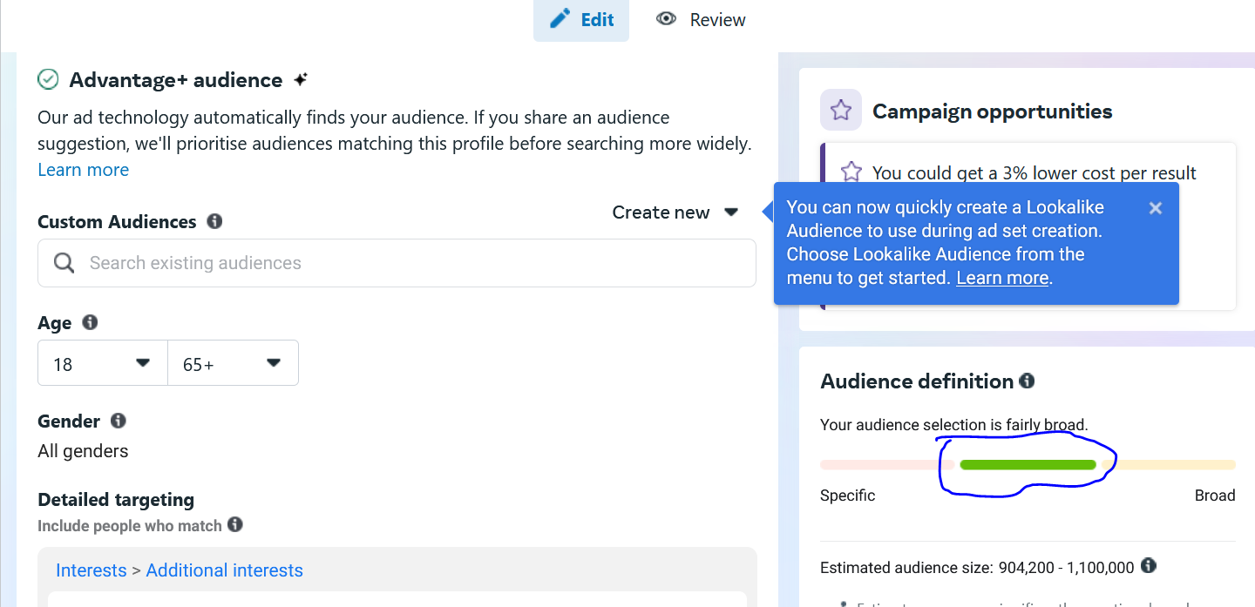

The green marked above line is telling that we are not too specific

If we become too much specific then Facebook will say that you are now too specific and will not recommend us to continue with our targeting

We can go more specific ad chose high school teacher in employers section

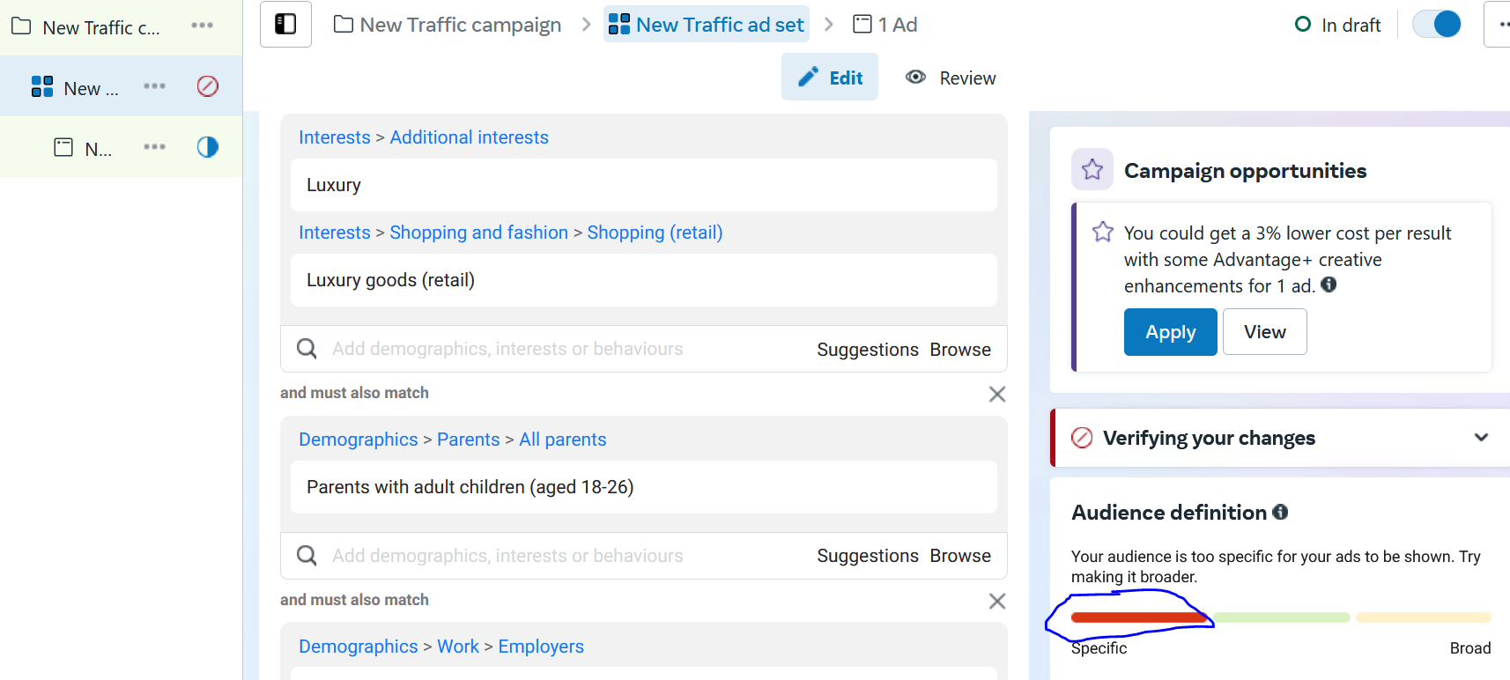

Now red line as marked above state that we are now very specific and it is also recommending us to make it broader as it is not good for our ad

We have to make audience so that we can be in green zone so that we have a decent audience size and it should not be small so we can reach more and more audience. And with that we should have a variation

**Phase 42**

**Case 3:**

Here we target people who have core interest in digital marketing

Suppose we have two type of people

One who are interested in Digital marketing we will just target simply broad audience that is digital marketing

Other who is interested in digital marketing and inside it SEMRush and inside it many thing then this things become specific that he has clear interest in it so we hve to narrow down

Now we make two ad group one targeting digital marketing>SEMRush>SEO

And then there is another ad group digital marketing>neil patel>moz

So I can create different variation

If we talk about people who are just interested in digital marketing then we can target digital marketing then where does the testing happens if we go by ad group method then we can analyse which ad group is performing better

We can also make other ad groups for testing purposes

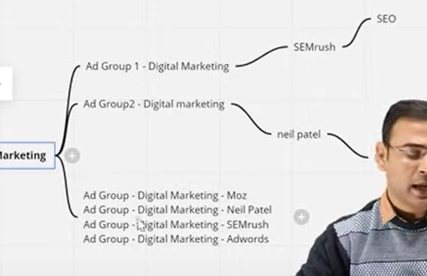

So what is this actually what you are thinking that How our audience should be like it is the ad group representation

**Phase 43**

If you do testing then you will get better results

Suppose we want to target people who are interested in real estate

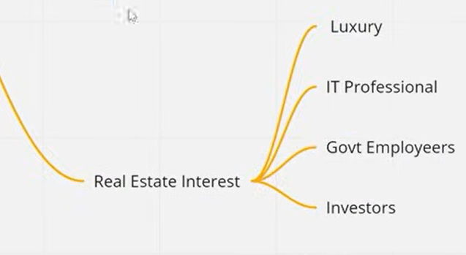

Then we can make four different ad group each targeting real estate interest but narrowing down differently in each ad group Until you do testing you will not getter result

After IOS 14 things have become more complicated now you have to target daily basis

If you think that by setting camapaign one time and I have targeted the audience and it will keep performing then It will not happen

So you should have different different thing and try to reach specific audience and also it is not that broad audience do not perform sometimes they work but still there should be option or scope that by narrow down we can understand the audience more properly

**Lesson 28:-**

In this lesson we will learn about **New Audience insights tools** we will understand what is audience insights tools and how it works. Since previous lessons we are focusing on audience creation or primarily we are focusing on creating better cold audience

Firstly we have talked about the saved option we get and we then talked about how to narrow it down so that we can reach accurate audience and how by narrowing down we will create different ad group and keep different audience in it and then test it.

Before starting it we need to learn about some important point before it

You need to understand that it will not give you any good audience means it will not give you directly audience but it provides you some hint by understanding the audience you have selected .Through this tool you can get insights about the audience like their age group from which city they are. So we are saying that it help us to research about our audience . We cannot say by building audience here we will final it no it is only for research work.

Another point you need to keep in mind id that Facebook has discarded Facebook insight tools

After July 2021 Facebook discontinued it and then after modifying it and changing it. With familiar features it introduced new tool which basically shows the feature in similar way and give the option insame way.

You can see this tool in business manager(old)

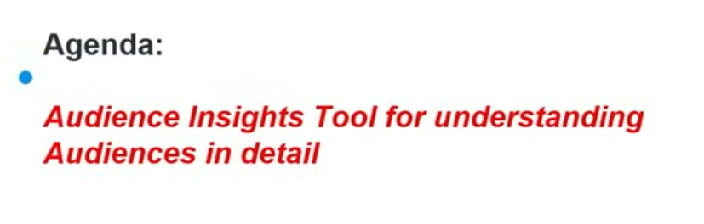

Now we will go to documentation with the following link

[https://www.Facebook.com/business/news/audience-insights](https://www.facebook.com/business/news/audience-insights)

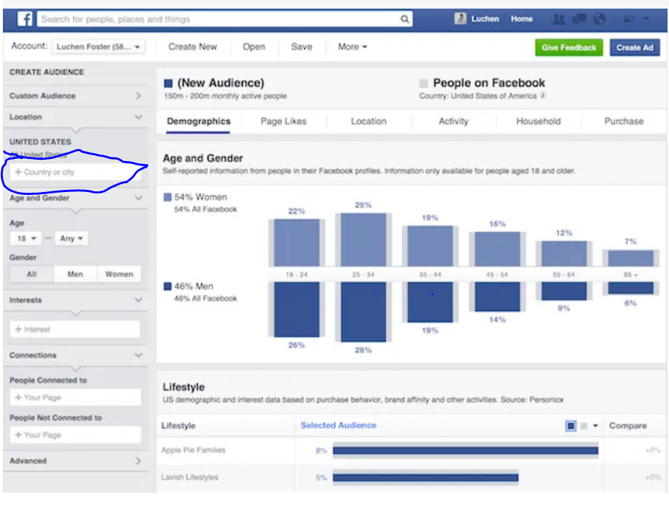

It was used to look like above and in marked area we used to tell the characteristics of our audience like its age group, country etc and what this audience is doiung in Facebook.

Now it is changed to Business Suite insights

Through this you can access even instagram audience

To reach this

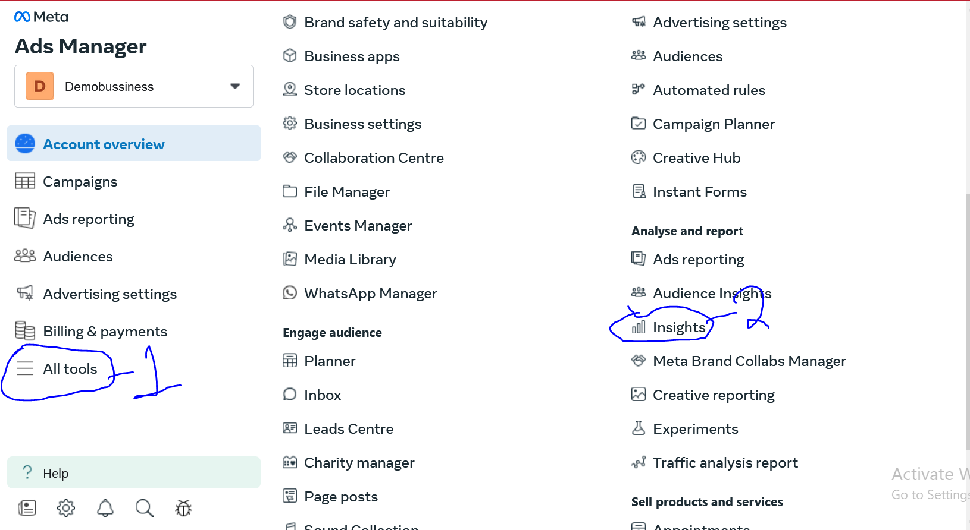

Go to All tools(as marked 1 above) and then to Insights(as marked 2) in ads manager

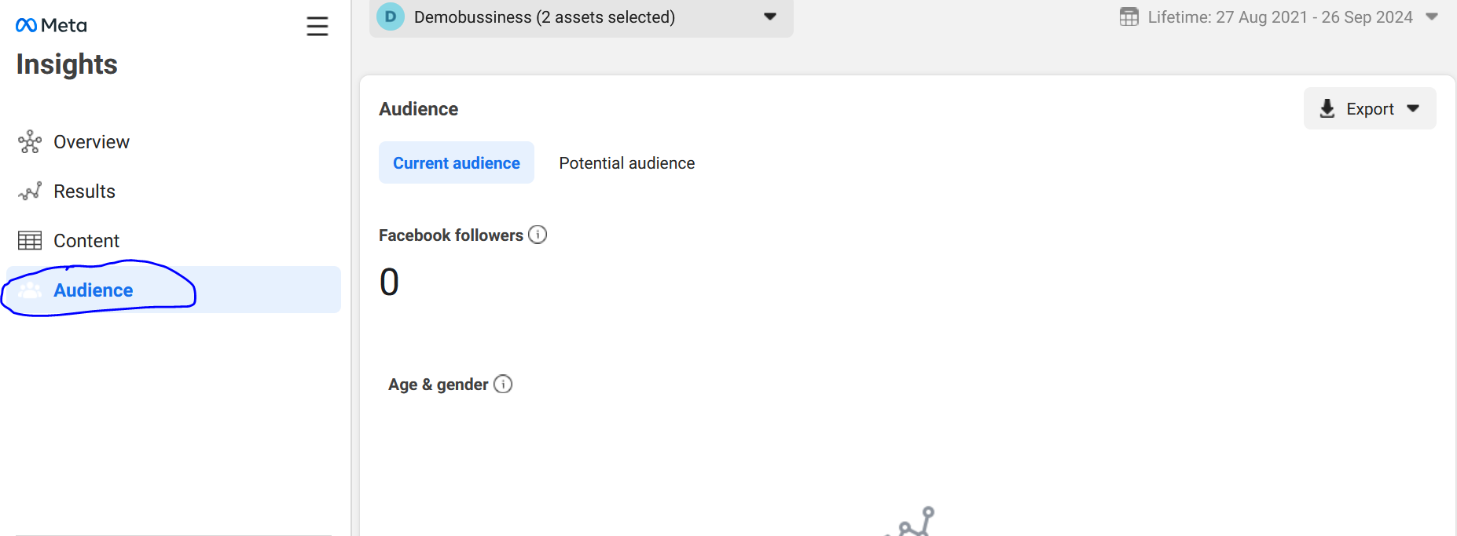

Now a new page will be opened now go to audience as marked above.

There is another way to reach it

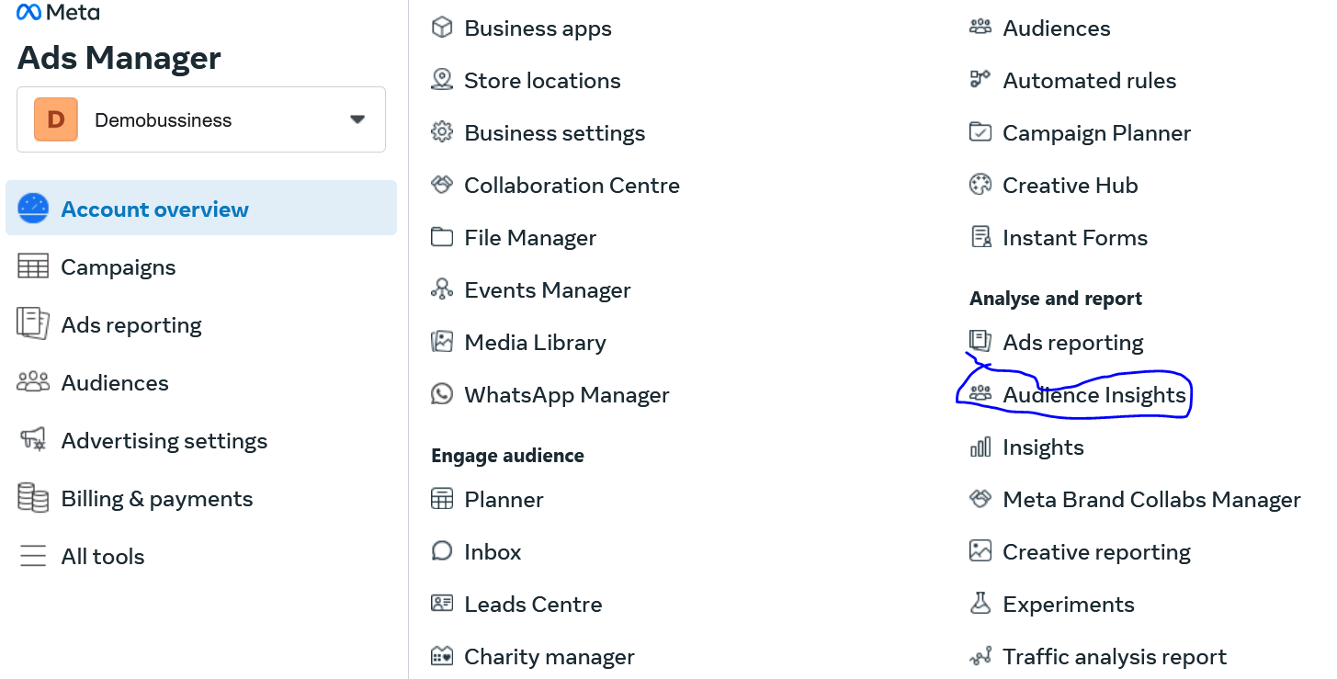

Just go to All tools and then to Audience insights

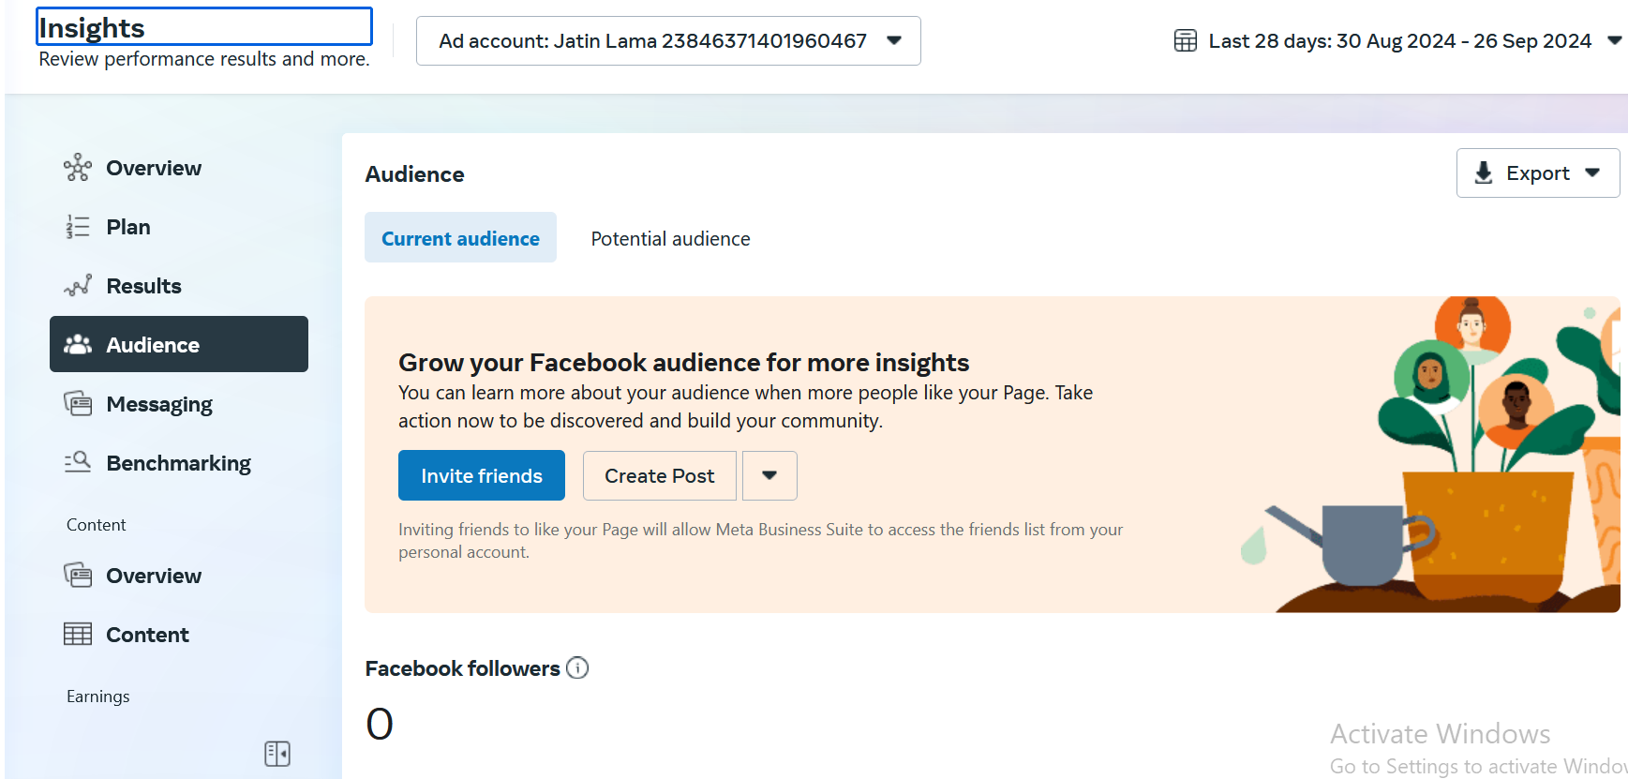

Now we will see from teacher perspective

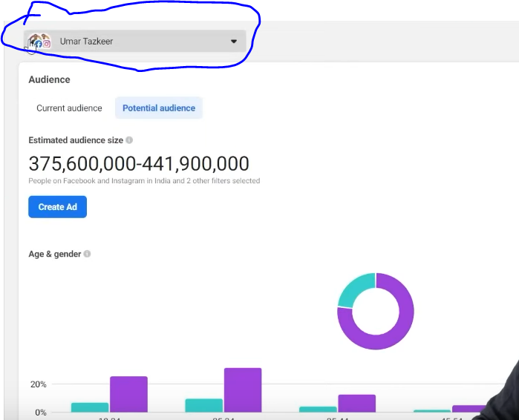

In marked above the option of account whose audience insight you want to see

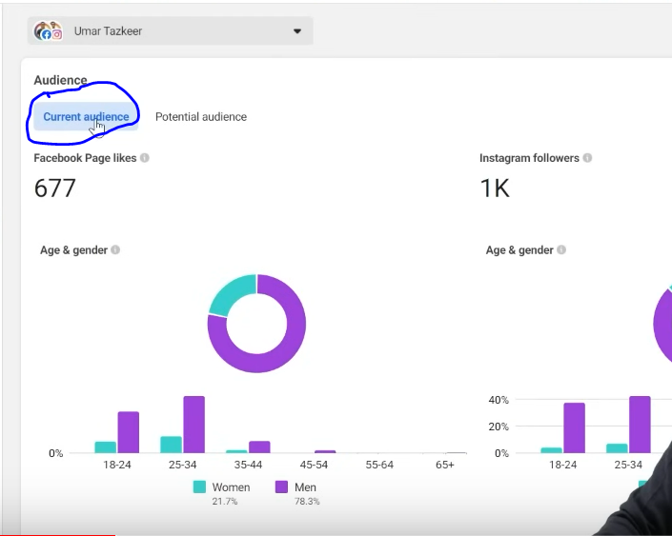

The marked one tell about the current audience

Now above you can see 677 likes on the page and 1k followers and below it you can see their characteristics

In above graph I can see that teacher have high men audience so I understand that I should target men.

Because people who are following my instagram are the one who will be interested in my services.

So we can get the insight that our prospect audience is men

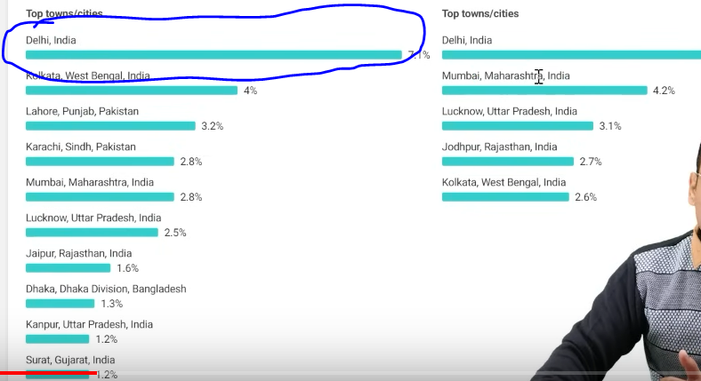

And from above I can see that most of the audience is from Delhi and Mumbai

So we need to understand that why not test audience in Delhi and Mumbai since audience come larger from theses areas so I understand from here that delhi can be an important location for us. From where I can get better audience because people follow me from here so by this you get an idea you cannot get exact audience from here you write these insights into excel.

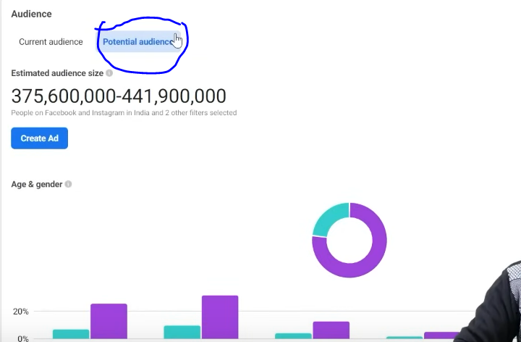

Now from marked above you can reach potential audience

By potential audience we mean overall how many audience are there in Facebook and Instagram in India

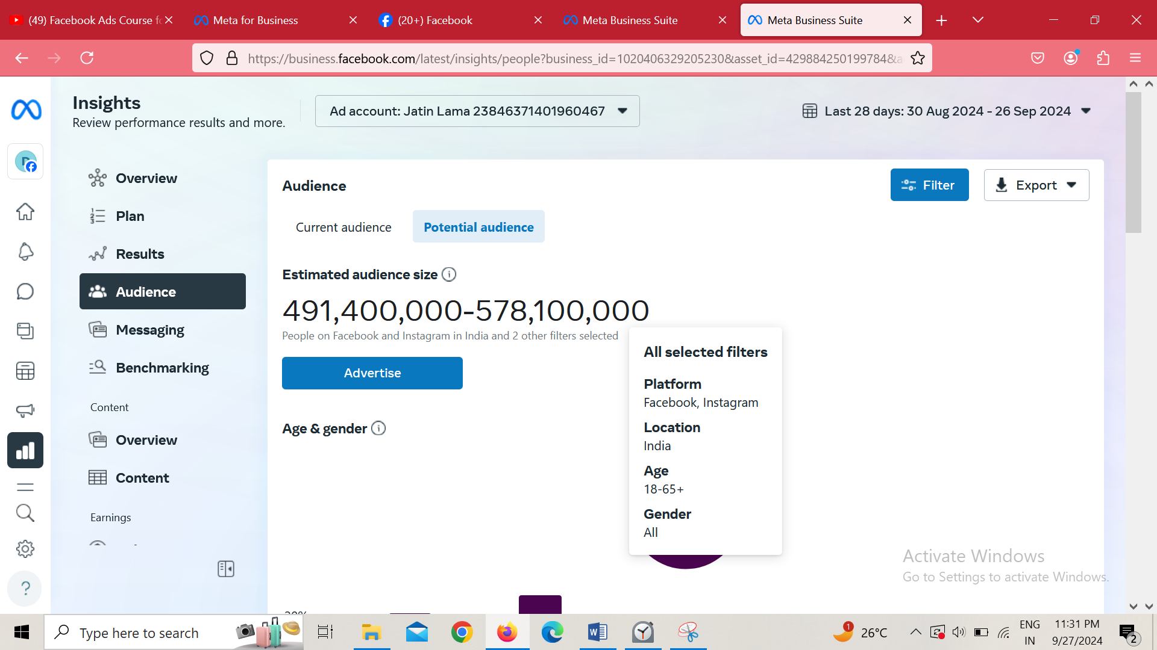

And here two filters added of location India,age group 0 to 65 and gender all, platform is Facebook and Instagram

Now we will filter it according to us

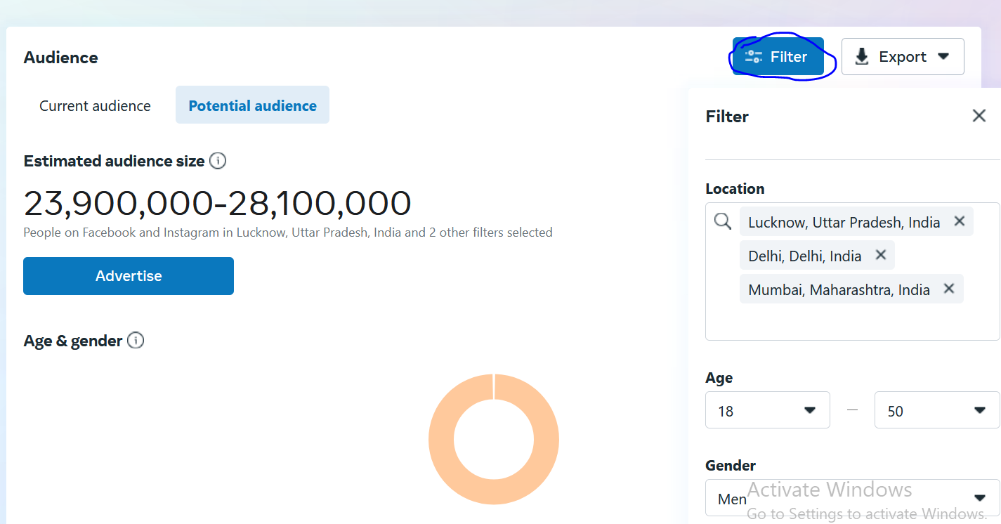

So to filter it click on filter as marked above

And then here you set the filter of Lucknow ,Delhi, Mumbai and then age is between 18 to 50 and gender is Male

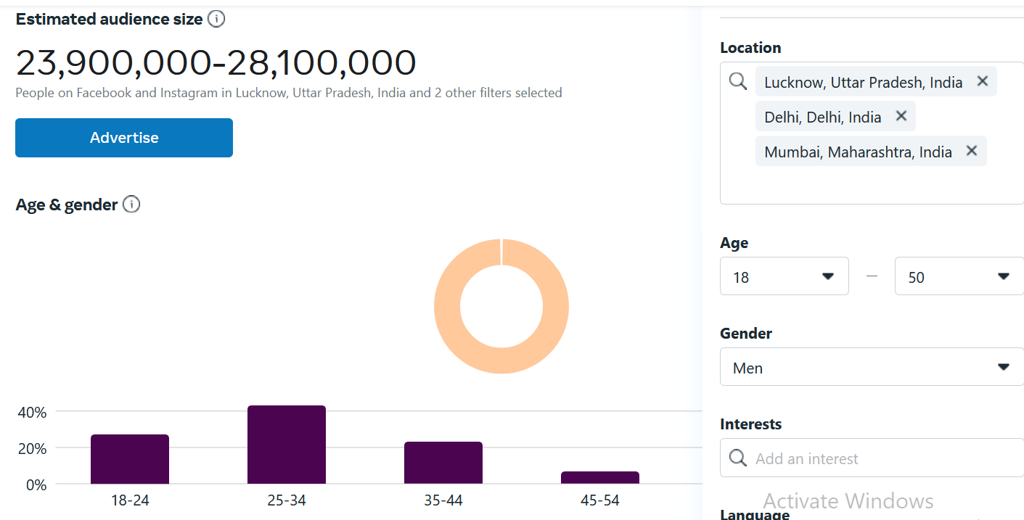

And now you can see the audience to which we can reach by this filter

And you can see the people of age group 25-34 are more

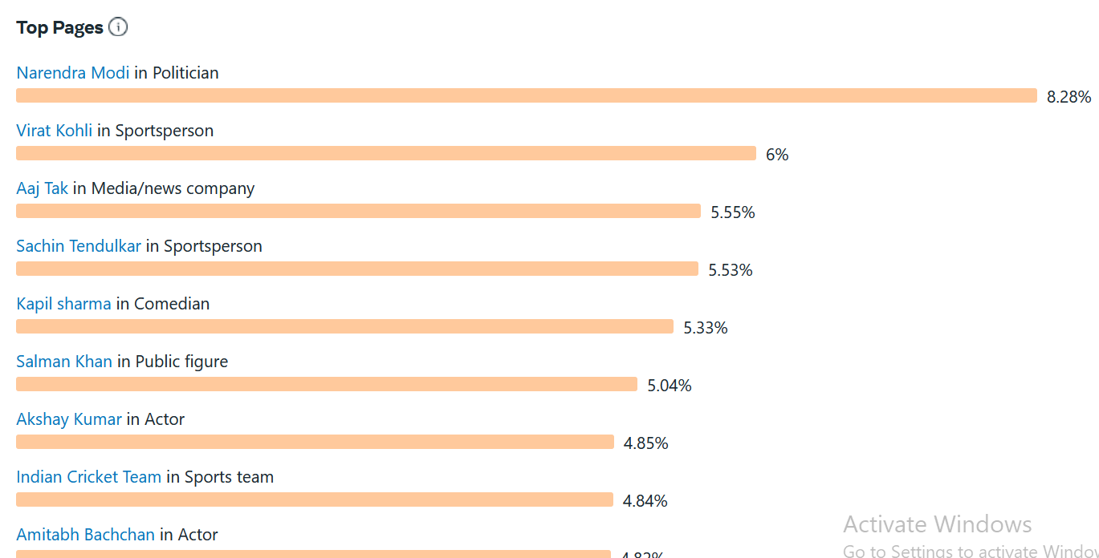

And these are the top pages they see

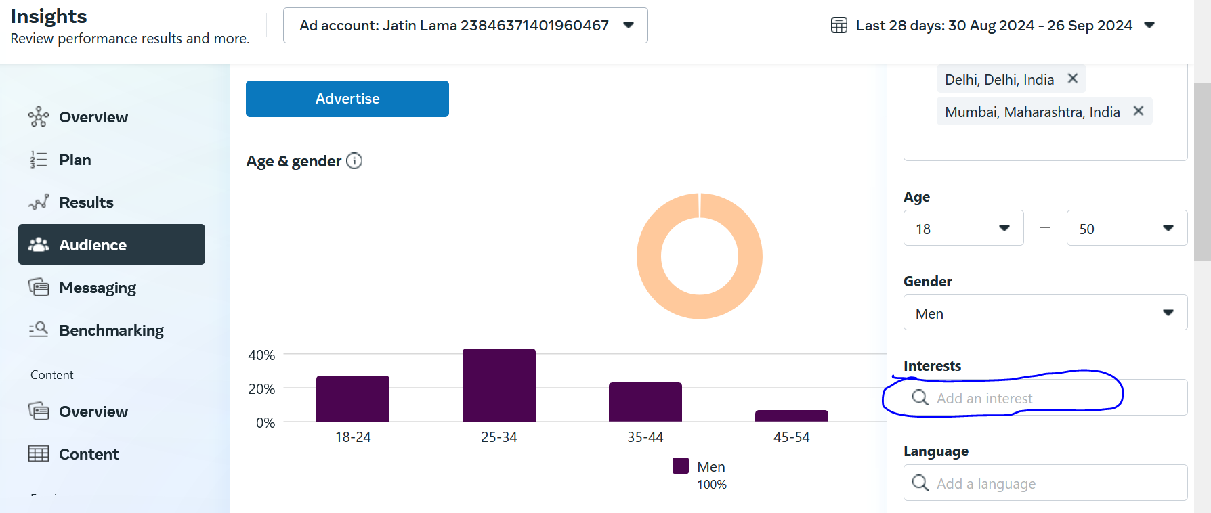

In marked above you filter audience according to the interest So now I will target people are interested in Moz which is a Marketing software because we want to target people interested in digital marketing

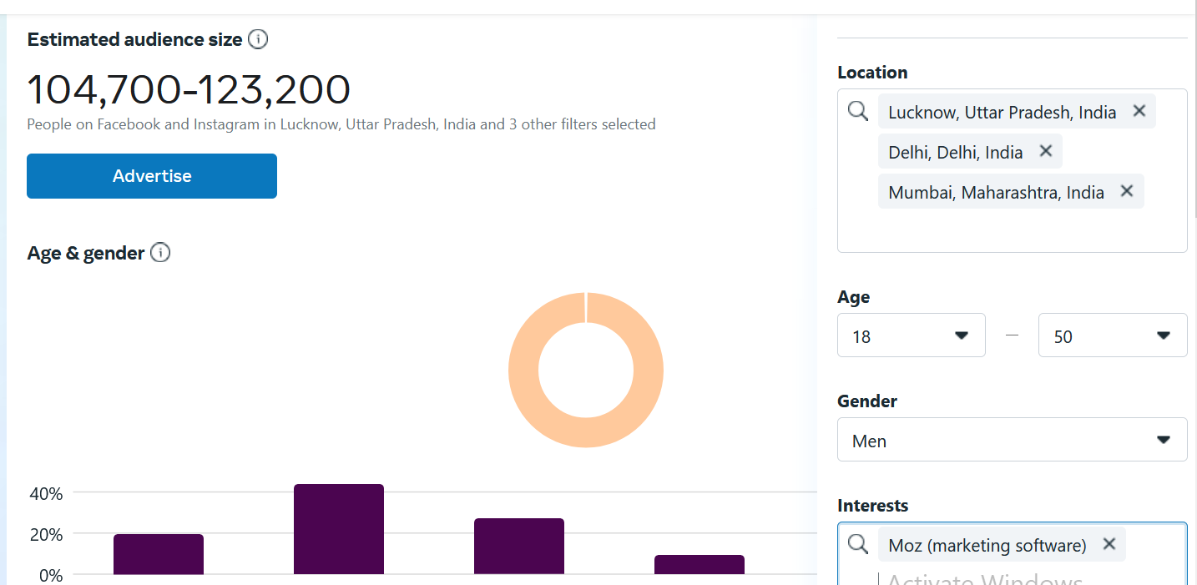

Now in above it shows 104,700 -123,200 audience range who is between age group of 18 to 50 and they are men.

**Phase 44**

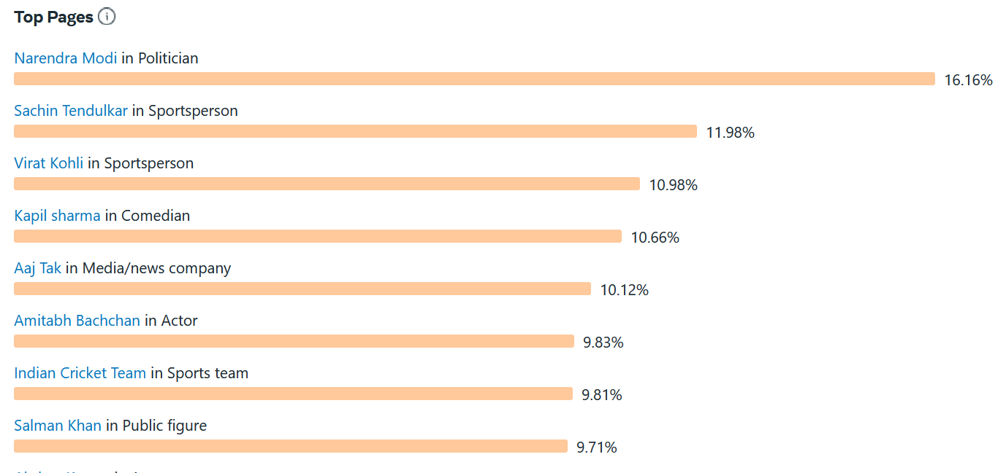These are the things these people search about the most

If we want we can do target on the basis of these things

Because I come to know about the people who are interested in Moz and between the age group of 18-50 years and live in these cities are interested in above people.

Now suppose it we filter on the basis of Neil patel (maybe a personality in Digital Marketing) and also do targeting in SEMRush

You just have to take idea from it

It is not like that follow these top pages so we will target on the basis of all.

For example there is narendra modi in politician but we are not targeting on the basis of politics so we will leave it.

It will not create you 100 percent audience but will give insight into the audience.

So we can do research by it.

By the way we get lot more information of audience in the older version of it but not in new version. You don’t get insights in detail in newer version in Audience insights.

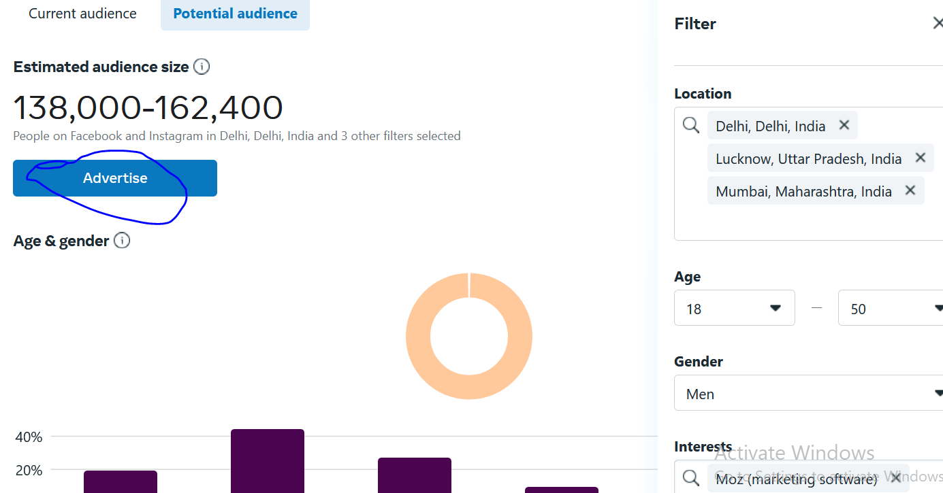

You can click on advertise button as marked above to make ad on the basis of this filter.

But you get more benefit on current audience tha tis myexisting and it follows me. From which city they are on.

In instagram insights you can get better result you can get there information like on what time people are online usually.

If we practically talk about people usually don’t use these tools

They use the option they see in Facebook ads to get saved audience while creating there campaign.

**Lesson 29:-**

In this lesson we will learn about **How to Find Hidden Facebook Audience**

So it is a paid tool that we are going to discuss and we will show its interface and show how to use it.

First we will discuss what problem it solves

Is this worth it

The teacher will show us its dashboard by login

And how the use this for what purposes. Whether the teacher get benefit from it or not.

What these tool do is that when you try to target according to

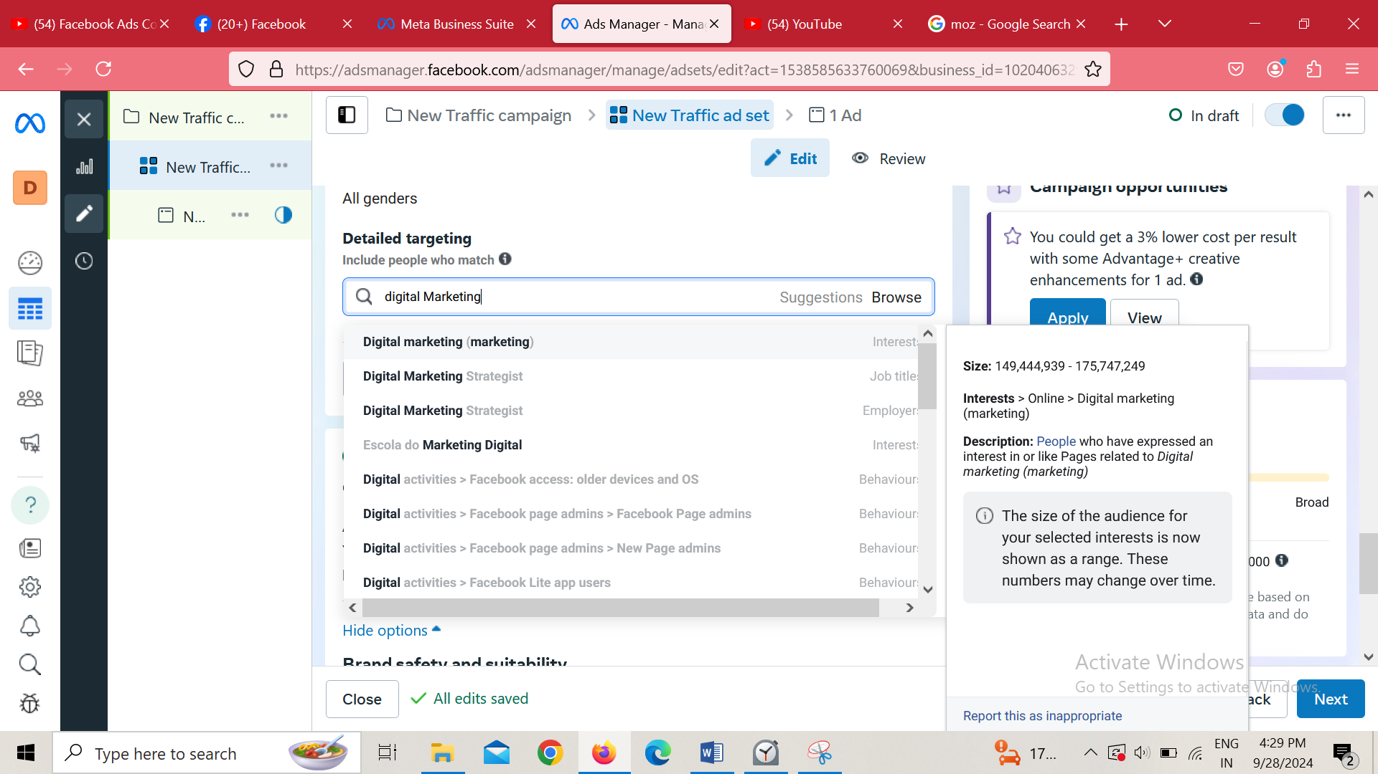

You may see that when you try to target people on the basis of topic then some suggestion is given to you but these are very few suggestion and your competitor also views this suggestion

So what happens is that the interest you are working on your competitors are also working So if you are working on same type of audience and same type of interest then you will not be able to create new audience properly and you are showing the ad to the audience of your competitor so your trying to target the people your competitor is targeting due to which you don’t get new audience.

The tool name is Interest Explorer

In there home page

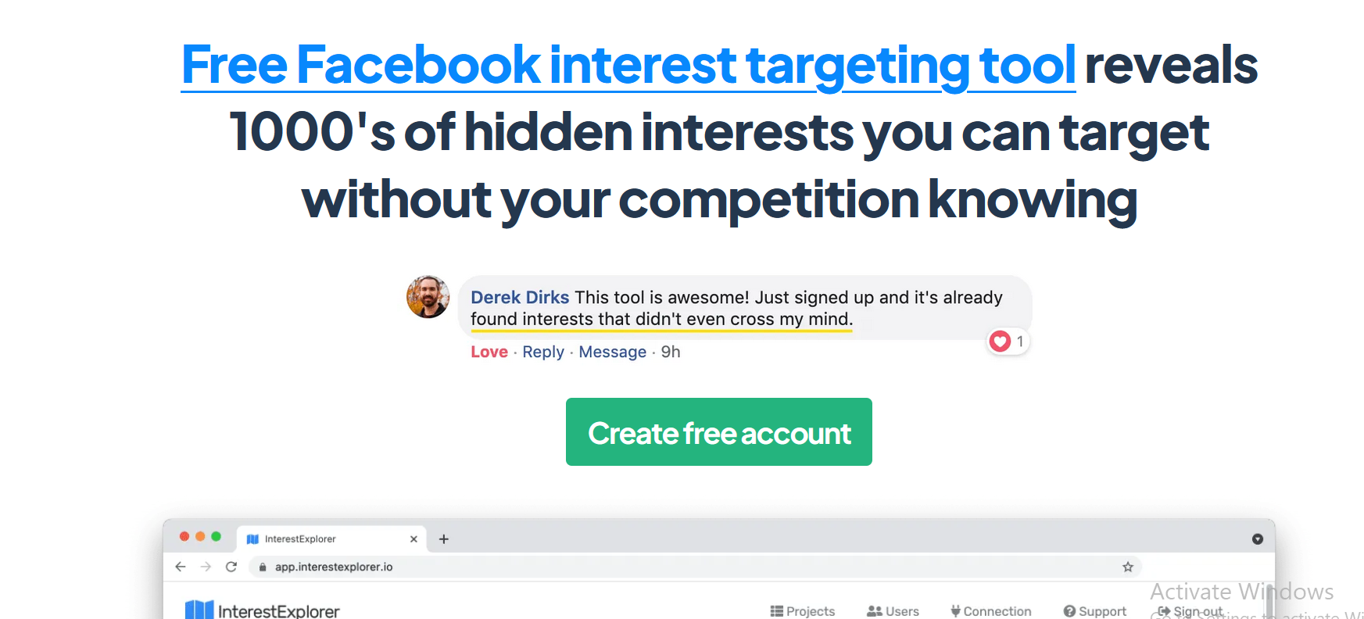

It says that It reveals hidden interest which can give you competitive edge

So by this tool you can get better and lot more suggestion and we can target them easily

What they are saying that they will organize the interest and increase number of suggestion you get

Yes these suggestion are hidden but it is not like that if you try to manually find it you will not find it

Teacher experience with it is like he mentions the primary interest and it give thousasnds of interest

related to it

With suggestion it also tells the audience size of there interest do here you get additional audience here

But if you do more hardwork then you can manually also find it in Facebook ad

You can try many keyword to know which one give you better result

You work will increase but this tool is not doing something that is not available in Facebook

You think by yourself that if it is giving you suggestion not present in Facebook then how you will target it.

It does not tell something different it just takes list of these interest from Facebook marketing API and just categories it and show you lots of option

So if I login into this website of Interest Explorer then I will see this type of UI

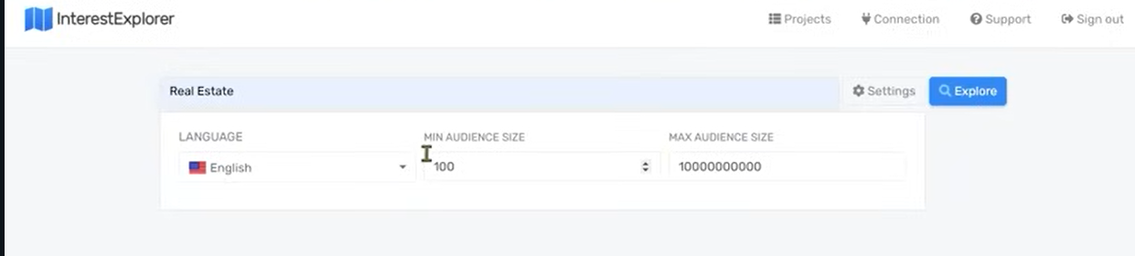

After telling the interest we can choose language by which this will show interest. After choosing this interest then ad will shown to the people who liked the pages in that language

And we can also choose minimum and maximum audience size here

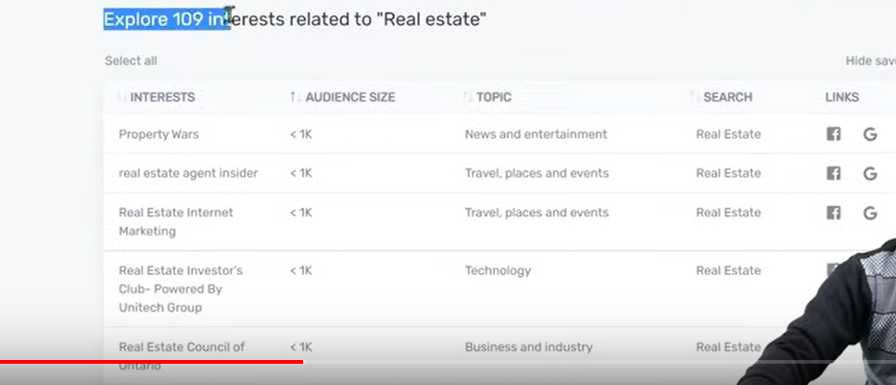

It is also giving 109 results which you does not see in normal Facebook campaign. It is also telling the audience size of interest

We also get this audience size information in Facebook ad when you hover over the suggestion

When this website categories it categories according to their own way

Teacher use this tool to get audience from it when he has no time

**Phase 45**

So this website will give you suggestion which Facebook usually don’t show you but it is present in Facebook. without it you have to find it yourself.

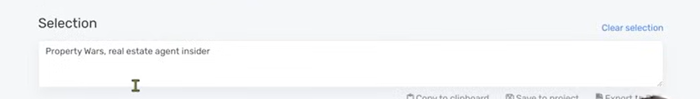

In above textbox you see the items that you selected you can copy from it and then use them in your targeting

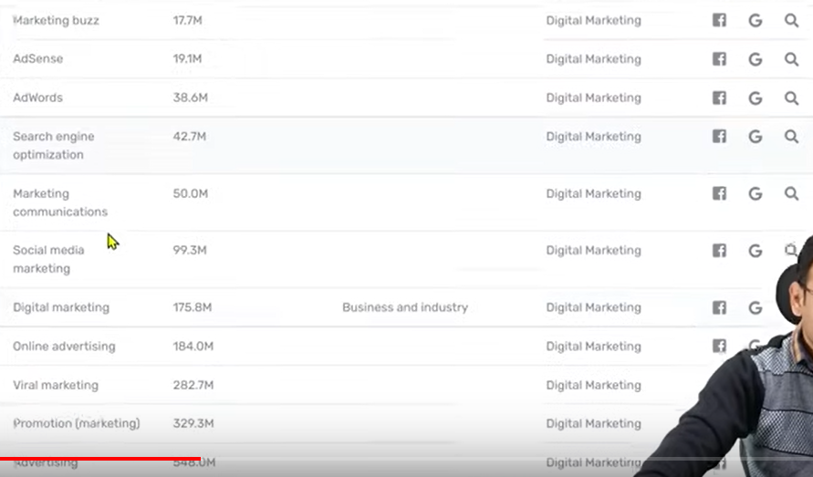

If we search Digital Marketing then it will show this list

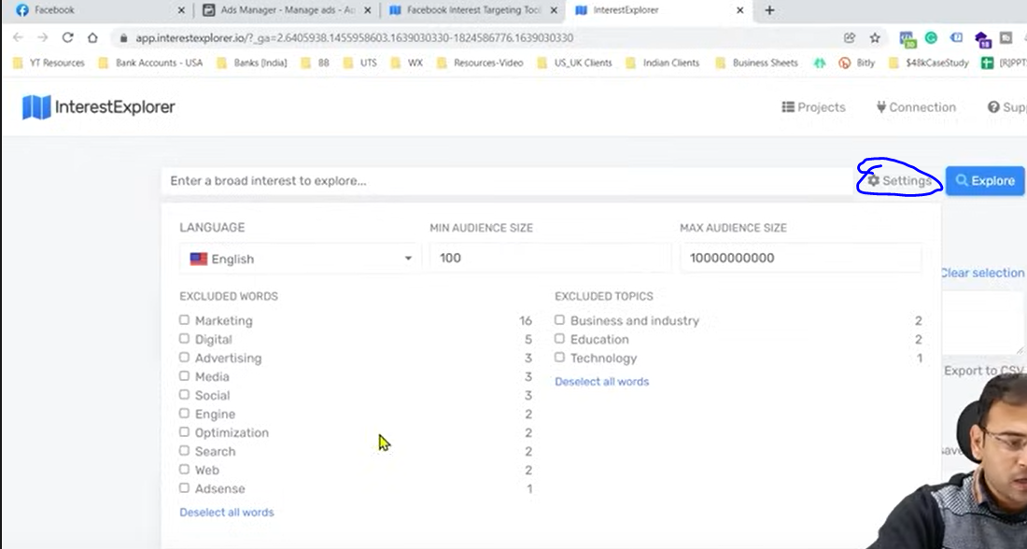

If you click on settings as marked above then you get lots of option to filter your result here. If Teacher want to exclude words then it can check the option mentioned in excluded words section in left side and you can exclude any topic by choosing option in right side

You can use this tool as an additional tool don’t be too dependent on it

Because the targeting you will do in detailed targeting is important how you are thinking and how you are targeting These tools will make your work easy but will not target all of the thing automatically for you.

Teacher got the benefit of speed in his work

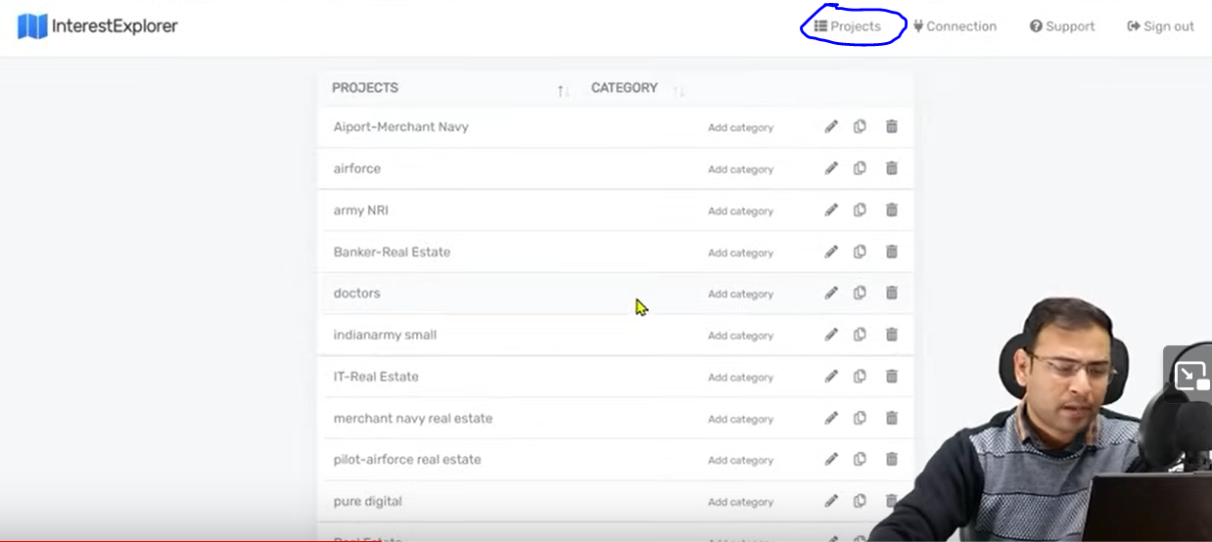

Teacher has also stored projects in projects section of the website by clicking on the projects as marked above

We have the option of creating project here (maybe saved search suggestion you will use in future and I think you can also categories those project)

We can generate idea from here but the final decision is here.

**Lesson 30:-**

In this lesson we will learn about Facebook detailed targeting audience

Whether its Facebook ads or Google ads

To make the user experience and audience experience better they keep bringing changes in their platform

So that user experience and audience experience does not get worse and he should not think that he is getting fake ads or he is being spammed with ads and advertiser should not think that the ads they run are not that effective and the platform is not able to bring them enough business and they could not run ads in a better way.

So that these platform bring updates regularly.

Teacher has seen that the updates are coming very frequently because there is a race between Google and Facebook .Both these platform want that more and more people should interact with them. So that they want more and more user base and they get revenue from these user base by ads so they keep in mind user experience.so they keep bringing regular updates

So here we are going to talk about Facebook ads audience update, we will talk about detailed targeting option here (maybe update).

<https://www.facebook.com/business/help>

You can follow link above

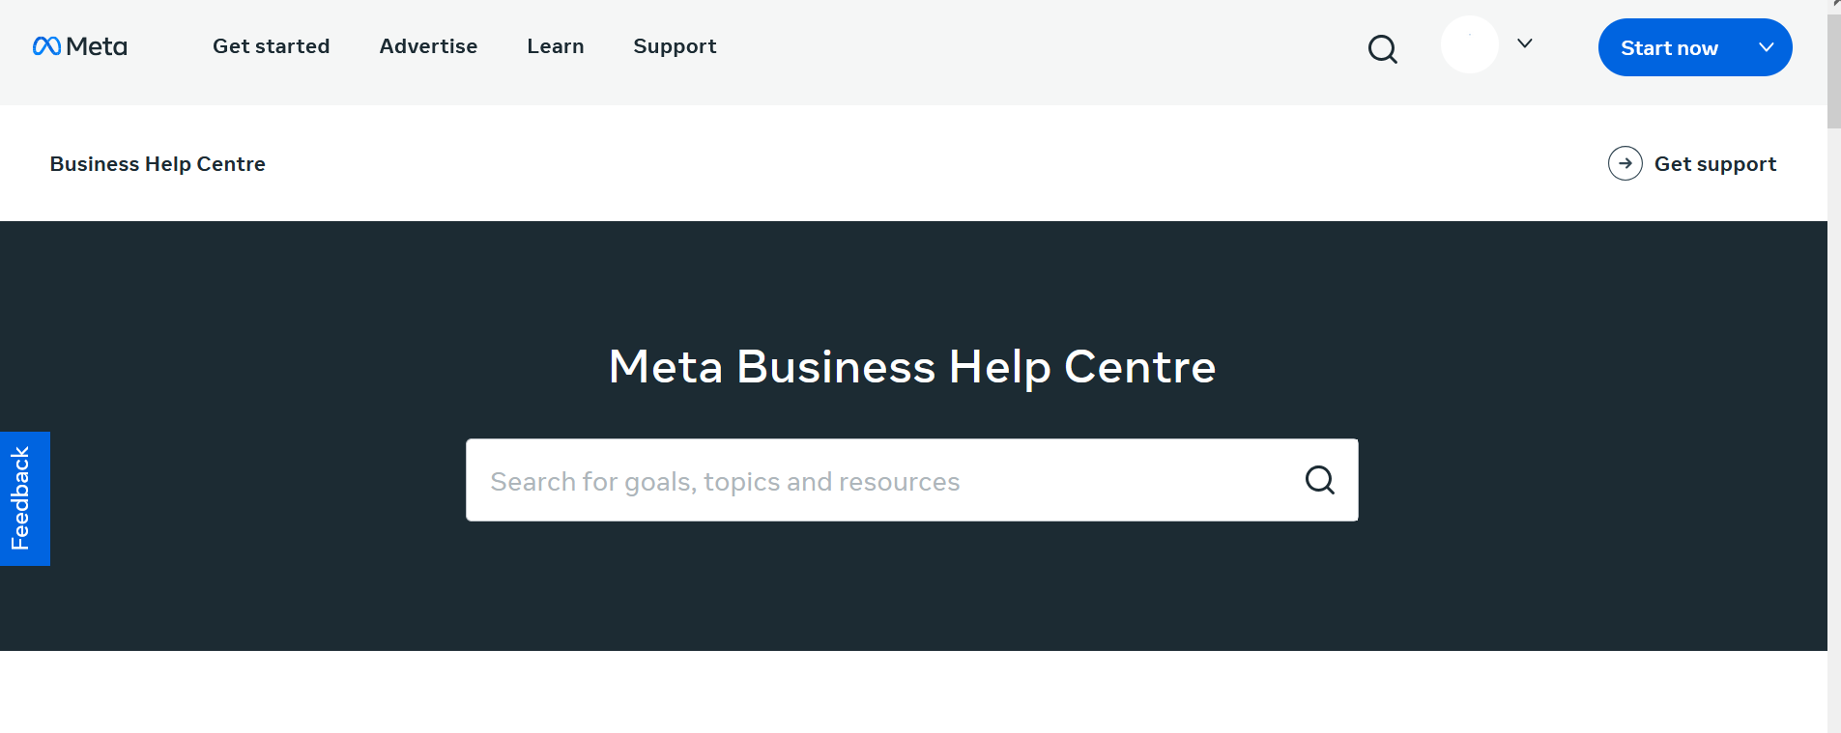

Now it will also Meta Business Help Centre

We will see from teacher perspective

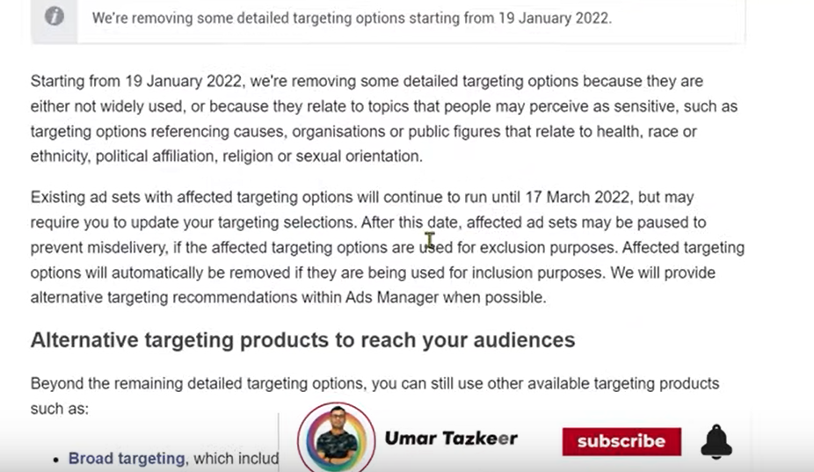this update suggest that after 19th January 2022 they are removing some targeting option from the Facebook because they offend people but the people whose ad is running on those option have the time of 17th March,2022 they need to change their targeting topics if they don’t do it then their ads maybe reach got effected.

SO this is a type od update which you see below thr help search bar

So basically It I stopping those people who are trying to deceive e facebook ad system and try to run some wrong ads or any type of product that the facebook does not allow and they bypass the fecbook policy so the facebook start becoming strict

That’s the reason your ad account may get blocked if the facebook get any even simple sign of policy break

So do your reseach yourself

**Lesson 31:-**

In this lesson we will learn about **Connection Targeting in Facebook Ads**

When we were doing audience targeting in Facebook we get a small option here that is Connection based targeting In recent times there has been some changes

So we will see how it works . What are the options inside it. We will discuss it practically here

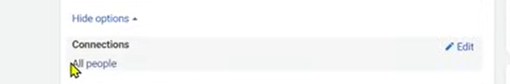

In above image that was how connections used to look like but I think it does not exist anymore because I cannot see it in my modern UI.

In this concept when We click on the edit button then below screen will be shown

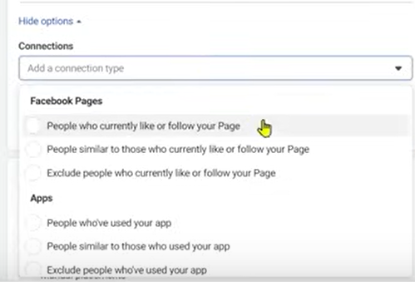

Here several option are given which are the option to make a mini audience and then narrow them down according to the topics mentioned in detail targeting and then show them ads

So suppose we chose People similar to those who currently like or follow your page

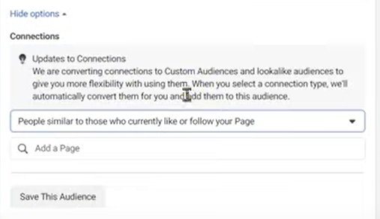

And then screen will look like above

And then mention your page in add a page field

After adding, it get access to your page followers and analyze these characteristics and then target similar people to those of your followers (same as lookalike audience) and add it to custom audience

**Phase 46**

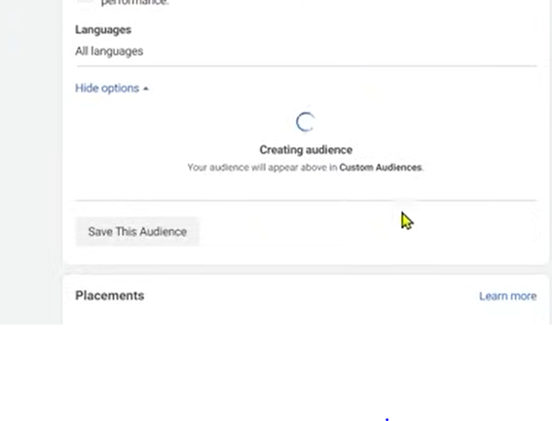

After adding page it will look like above screen

Then

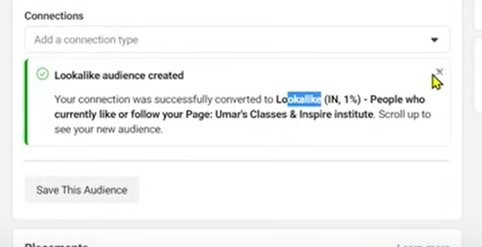

You can see it added to custom field

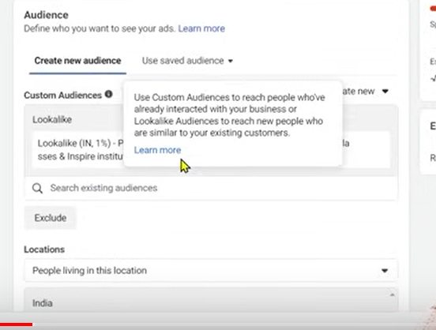

You can now see your audience is getting specific

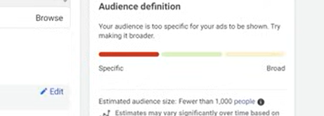

If we remove that custom audience then it will show like this

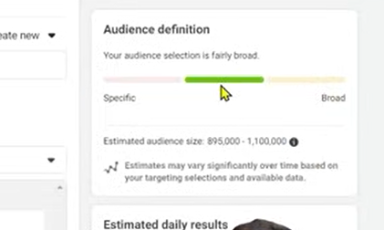

So here we are making custom audience based on connection

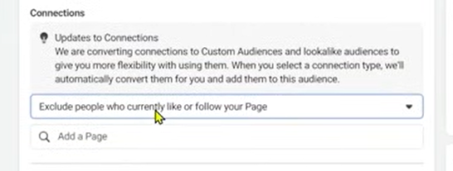

You can similarly exclude people who follow or like your page because they offcourse view your ad without targeting

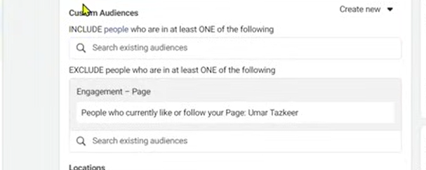

Now you can see it in excluded list of custom audience

And your reach may decrease by it.(who knows)